**CHAPTER 3: SYSTEM DEVELOPMENT**

**3.1 Project Management Strategy and Tools**

A project is a unique, transient endeavor, undertaken to achieve planned objectives, which could be defined in terms of outputs, outcomes or benefits. A project is usually deemed to be a success if it achieves the objectives according to their acceptance criteria, within an agreed timescale and budget [1]. Project management, then, is the application of knowledge, skills, tools, and techniques to project activities to meet the project requirements. Project management brings a unique focus shaped by the goals, resources and schedule of each project [2].

**3.1.1 Project Workflow and Schedule**

* Team Size: 1
* Total Project Duration: 10 weeks
* Effort Required per person: 20 hours per week

**3.1.2 Project Team**

**Table 1: Team Resource and Roles**

|  |  |
| --- | --- |
| **Team Resource** | **Role** |
| Er.Rajan Karmacharya | Supervisor |
| Sarita Karki | Developer/Designer |

Table 1 shows the member associated with the design and development of the project. Project supervisor has the responsibility of observing throughout the project development and provide guidance for each phase of the project. The project managers are required to prepare their design and develop the project according to the necessary criteria and under direct supervision of the supervisor.

**3.1.3 Responsibilities**

The different roles and responsibilities were done by the team member using the knowledge and skills she had. The supervisor initiated the project’s various aspects and enhanced project quality through effective mobilization and encouragement of the team member as well as monitoring overall project. The team member has the responsibility to do research on the project to meet each objective of the project

**Responsibilities of Supervisor**

* Schedule the project
* Help understand performance and goal of project
* Provide essential information
* Track the progress of the project
* Provide real-time feedback
* Share the information and experience
* Assist in resolving emergencies
* Motivate and encourage the team members

**Responsibilities of team member**

* Preliminary research regarding the project
* Background reading
* Design and Analysis Development and Testing
* Implementation and System Evolution
* Draft report writing and submission
* Final report writing and submission

**3.1.4 System Development Tools**

**3.1.4.1 NetBeans**

NetBeans is an open-source integrated development environment (**IDE**) for developing with Java, PHP, C++, and other programming languages. NetBeans is also referred to as a platform of modular components used for developing **Java** web applications. NetBeans is coded in Java and runs on most operating systems with a Java Virtual Machine (**JVM**) [3].

NetBeans was used as the IDE for this project. It was useful for this project to compile the java code and run it easily in small time. Similarly, it also helped to connect to the database quickly using the Glassfish server.

**3.1.4.2** **Java**

Java is a programming language and computing platform first released by Sun Microsystems in 1995. Java is fast, secure, and reliable [4]. The Java Plug-in software is a component of the Java Runtime Environment (JRE). The JRE allows applets written in the Java programming language to run inside various browsers The Java Plug-in software is a component of the Java Runtime Environment (JRE) [5].

Java was used as the server-side scripting language. Most of the business logics were coded using Java.

**3.1.4.3 Mysql**

MySQL is a Relational DataBase Management System (RDBMS). MySQL operates using client/server architecture in which the server runs on the machine containing the databases and clients connect to the server over a network. It uses SQL server, Client programs for accessing the server and client library for writing your own programs [6].

MySQL was used as the database. All the database tables were created using MySQL and the required data and files were inserted using MySQL queries.

**3.1.4.4 Java Server Pages(JSP)**

Java Server Page (JSP) is a technology for controlling the content or appearance of Web pages through the use of [servlet](https://searchmicroservices.techtarget.com/definition/servlet)s, small programs that are specified in the Web page and run on the Web server to modify the Web page before it is sent to the user who requested it[8].

JSP was used as the server-side scripting language. It was used to insert both the HTML tags for designing web pages and to insert the Java for using logics. Another main part of JSP was in uploading and downloading files using servlet.

**3.1.4.4 Draw.io**

Draw.io is an open source technology stack for building diagramming applications, and the world’s most widely used browser-based end-user diagramming application. With simple drag and drop techniques, it was used to darw the context diagram, flow charts, ER-Diagram, Sequence diagram and use case diagram.

**3.1.4.5 Microsoft Word**

Microsoft word as a word-pressing program was used to write all the reports about the project.

The documentation of the project was done using it since from the beginning of the report writing.

**3.2 System Analysis**

System analysis is a process of collecting and interpreting facts, identifying the problems, and decomposition of a system into its components. It improves the system and ensures that all the components of the system work efficiently to accomplish their purpose [9]. It can include looking at end-user implementation of a software package or product and looking in-depth at source code to define the methodologies used in building software [10].

In this project, the preliminary task was to get the basic knowledge on knowledge management. The project also had to remain feasible for implementation in normal classrooms of colleges. After the research the tools were finalized like NetBeans for the medium project like this. Similarly, the time and risk were analyzed before proceeding with this project. The analysis phase of the project can be divided into the following phases:

* Feasibility Study
* Problem/ Risk Analysis
* Requirement Analysis
* Design and coding
* Decision Analysis
  1. **System Design**
     1. **Data Flow Diagram**

A data flow diagram (DFD) maps out the flow of information for any process or system. It uses defined symbols like rectangles, circles and arrows, plus short text labels, to show data inputs, outputs, storage points and the routes between each destination[11].

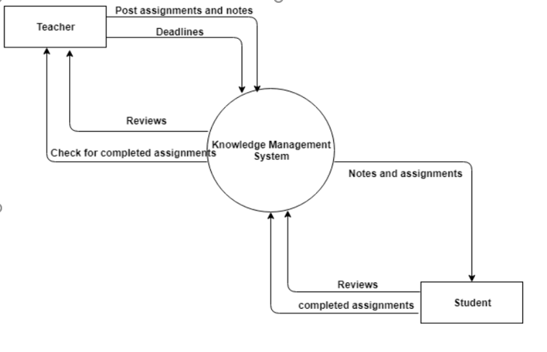

**Fig : Context Flow Diagram**

The above figure explains the DFD level 1 for the project. It shows the entities teacher and student and the Knowledge Management System.

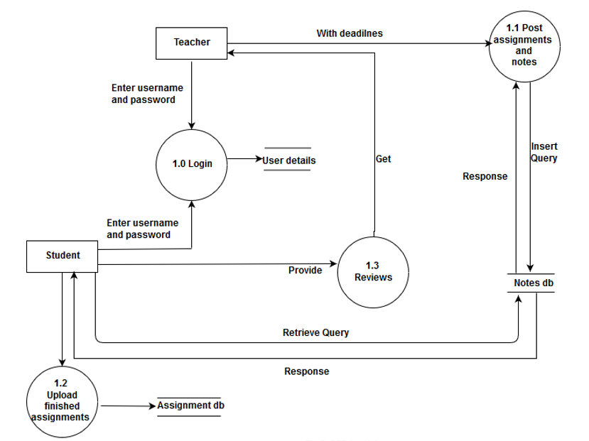

**Fig: DFD level 1**

The above figure is the DFD level 1 for the project. It explains the flow of data from process to process. The processes are denoted by the circle.

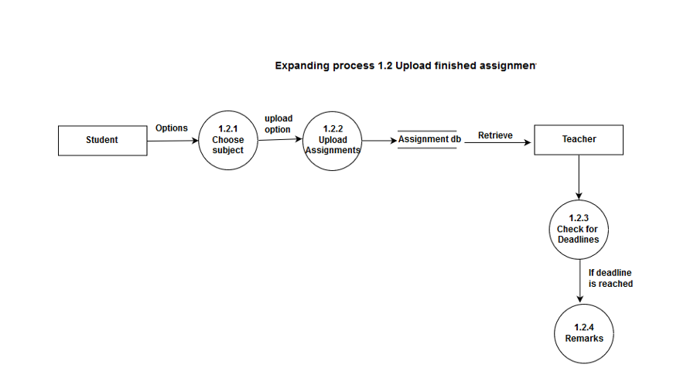

**Fig: DFD level 2**

The above figure is the expansion of the process 1.2 upload notes and assignments. It provides the sub-processes of that process.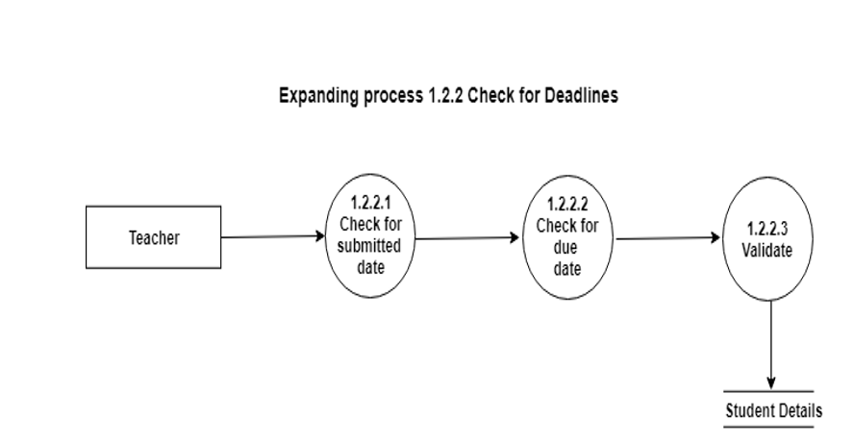

**Fig : DFD level 3**

Above is the figure for DFD level 3 which further explains the sub-process checking for details. It shows the storage of remarks in the database.

**3.3.2 ER Diagram**

An entity-relationship diagram (ERD) is a data modeling technique that graphically illustrates an information system's entities and the relationships between those entities. An ERD is a conceptual and representational model of data used to represent the entity framework infrastructure [12].

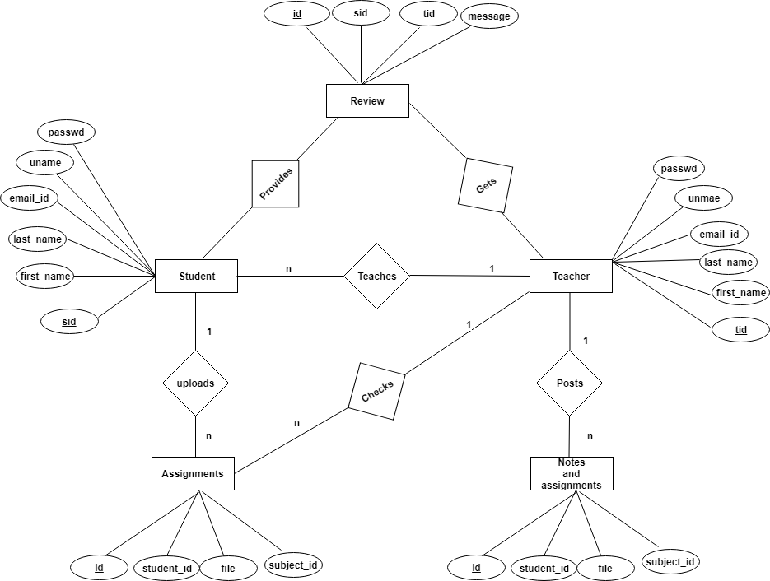

**Fig : ER- Diagram**

Above is the ER- Diagram for the project. It includes the entities attributes and the relations as shown in the figure. It describes the relation between teacher and student clearly.

**3.3.3 Flow chart**

A flowchart is a type of diagram that represents an algorithm, workflow or process. The flowchart shows the steps as boxes of various kinds, and their order by connecting the boxes with arrows. This diagrammatic representation illustrates a solution model to a given problem [13].

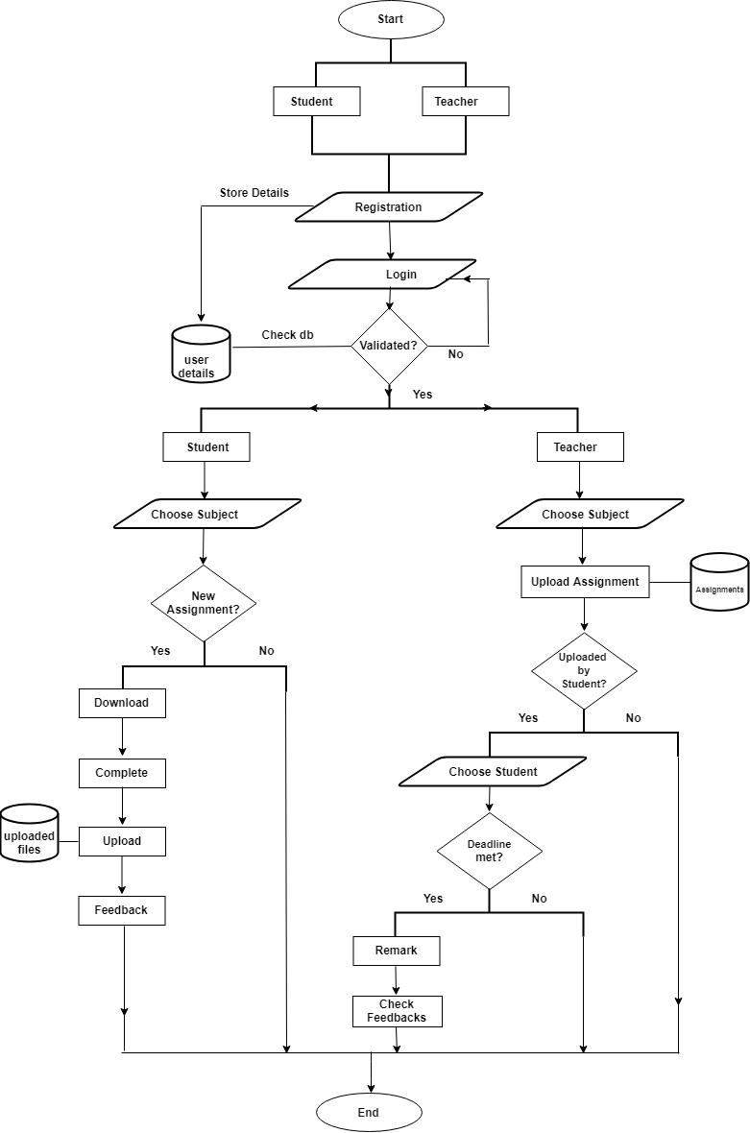

**Fig: Flowchart**

Fig describes the flowchart for the system developed. It shows how data are entered by the user into the system, how the system validates them and then finally provides response to the user. At, the end both the users exit from the system.

**3.3.4 Database Schema**

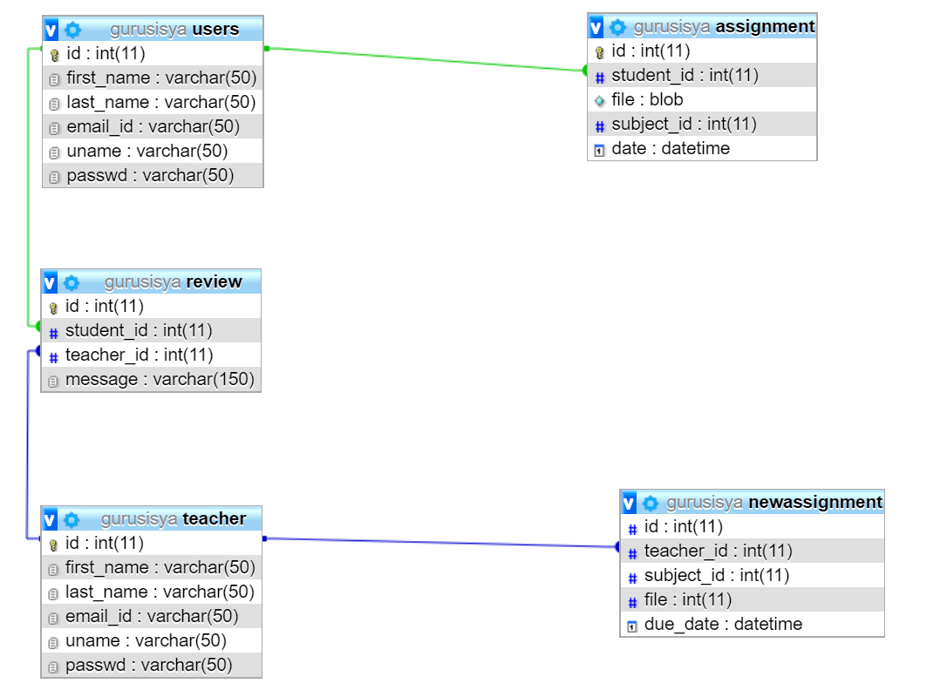

Fig: Database Schema

Fig shows the database schema for the system. The relationship between the tables is established through the foreign key. The attributes of the elements are clearly shown above.

**3.3.5 Use case diagram**

UML Use Case Diagrams. Use case diagrams are usually referred to as behavior diagrams used to describe a set of actions (use cases) that some system or systems (subject) should or can perform in collaboration with one or more external users of the system (actors) [14].

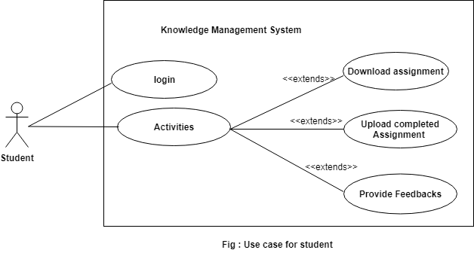

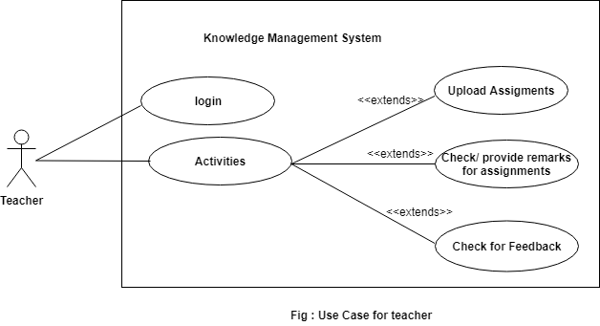

Fig: Use case diagrams

Two figures above describe the use case diagram where the actors are teacher and the students. The actions are shown by the tag extends. They can perform the activities after they login to the system.

**3.3.6 Sequence diagram**

Sequence diagrams are sometimes called event diagrams or event scenarios. A sequence diagram shows, as parallel vertical lines (lifelines), different processes or objects that live simultaneously, and, as horizontal arrows, the messages exchanged between them, in the order in which they occur [14].

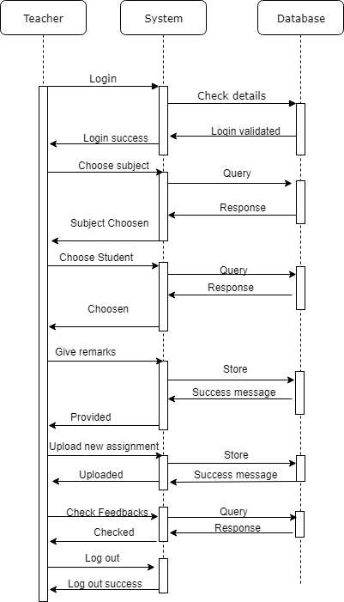

Fig: Sequence diagram for teacher

Fig above is the sequence diagram for the teacher. It shows the sequence of the acitivites that the teacher goes after entering into the system.

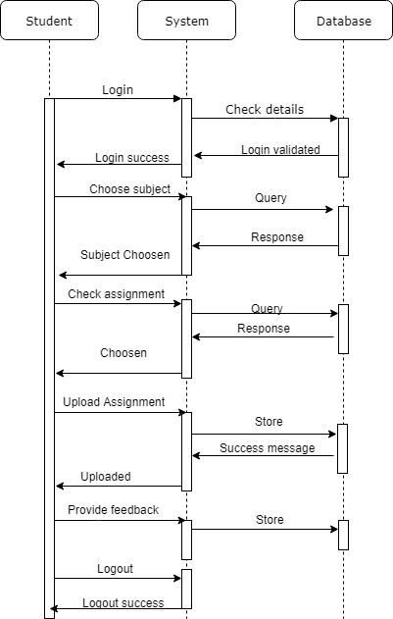

Fig: Sequence diagram for student

Fig shows the sequence diagram for the student like that of the teacher. Students also go through the sequence of above activities after they enter into the system.

**3.4 Project Schedule**

The project schedule is a schedule is a listing of a project's milestones, activities, and deliverables, usually with intended start and finish dates.

**3.4.1 Time Schedule**

The detailed time schedule of this project is explained below.

**Table 2: Time Schedule Table**

|  |  |  |  |  |
| --- | --- | --- | --- | --- |
| Task Id | Task | Start Date | Duration | End Date |
| 1 | **Preliminary Analysis** |  |  |  |
| 1.1 | Planning | 43179 | 4 | 03/23/2018 |
| 1.2 | Analysis | 03/24/2018 | 5 | 03/28/2018 |
| 1.3 | Meeting with Supervisor | 03/29/2018 | 5 | 04/02/2018 |
| 1.4 | Background Study | 04/03/2018 | 3 | 04/05/2018 |
| 1.5 | Preparation of Project Proposal | 04/05/2018 | 4 | 04/10/2018 |
| 1.6 | Preparation of GANTT chart and Project Schedule | 04/08/2018 | 2 | 04/09/2018 |
| 1.7 | Approval from Supervisor | 04/10/2018 | 1 | 04/10/2018 |
| 2 | **Research Work** |  |  |  |
| 2.1 | Research on Knowledge Management | 04/04/2018 | 5 | 04/08/2018 |
| 2.2 | Research on File Handling | 04/09/2018 | 5 | 04/13/2018 |
| 2.3 | Research on Java and JSP tools | 04/14/2018 | 3 | 04/16/2018 |
| 3 | **Design** |  |  |  |
| 3.1 | Application Design |  |  |  |
| 3.1.1 | Context Diagram | 04/25/2018 | 2 | 04/29/2018 |
| 3.1.2 | Data Flow Diagram | 04/30/2018 | 3 | 04/02/2018 |
| 3.1.3 | Use Case Diagram | 04/03/2018 | 1 | 04/04/2018 |
| 3.1.4 | Sequence Diagram | 04/05/2018 | 1 | 04/06/2018 |
| 3.1.5 | Flowchart | 05/06/2018 | 1 | 05/06/2018 |
| 3.1.6 | Design User Interfaces | 05/07/2018 | 2 | 05/08/2018 |
| 4 | **Implementation** |  |  |  |
| 4.1 | Interface Design | 05/10/2018 | 10 | 05/19 |
| 4.2 | Program Coding | 05/20/2018 | 8 | 05/27/2018 |
| 5 | **Testing** |  |  |  |
| 5.1 | Unit Testing | 05/27/2018 | 1 | 05/27/2018 |
| 5.2 | Integration Testing | 05/28/2018 | 2 | 05/29/2018 |
| 5.3 | System Testing | 05/30/2018 | 2 | 06/02/2018 |
| 6 | **Dissertation** |  |  |  |
| 6.1 | Draft Report | 06/03/2018 | 6 | 06/08/2018 |
| 6.2 | Final Report | 06/18/2018 | 5 | 06/22/2018 |
| 6.3 | Report Evaluation and Conclusion | 06/23/2018 | 6 | 06/28/2018 |
| 6.4 | Submission of Final Draft | 07/10/2018 | 3 | 07/12/2018 |
| 6.5 | Correctness of Final Draft | 07/13/2018 | 3 | 07/15/2018 |
| 7 | **Final Phase** |  |  |  |
| 7.1 | Final Documentation Printing and Binding | 07/15/2018 | 2 | 07/16/2018 |
| 7.2 | Document Submission | 07/16/2018 | 1 | 07/16/2018 |
|  |  |  |  |  |

**3.4.2 GANTT Chart**

The Gantt chart of this project is represented in the figure below, which shows all the activities that we carried out for this project and the time scale and the overall time schedule. The Gantt chart helps to visualize the overall processes involved in Smart Penalty System at once.

**3.5 Testing**

**3.5.1 Unit Testing**

Unit testing is a level of software testing where individual units/ components of a software are tested. The purpose is to validate that each unit of the software performs as designed. A unit is the smallest testable part of any software. It usually has one or a few inputs and usually a single output. In procedural programming, a unit may be an individual program, function, procedure, etc. In object-oriented programming, the smallest unit is a method, which may belong to a base/ super class, abstract class or derived/ child class. (Some treat a module of an application as a unit [10].

**3.5.2 System Testing**

System Testing is the testing of a complete and fully integrated software product. Usually software is only one element of a larger computer-based system. Ultimately, software is interfaced with other software/hardware systems. System Testing is a series of different tests whose sole purpose is to exercise the full computer-based system [11].

**Table 3: Test cases**

|  |  |  |  |  |  |
| --- | --- | --- | --- | --- | --- |
| Test Case No. | Description | Expected Result | Actual Result | Status | Conclusion |
| Test Case 1 | Test for assignments submission by teacher | Submission successful if  same file is not uploaded before | Successful | True | File submitted successfully |
| Test Case 2 | Test for assignment view submitted by students | View only the assignments of his/her subject and download | Successfully  Viewed and was able to download | True | Assignment list viewed successfully |
| Test Case 3 | Test for review view by teacher | View only his/her review | Only his/her review viewed | True | Review shown only to the one who logs in |
| Test Case 4 | View the new assignments by student | View the distinct list of assignment of selected subject | Successfully listed and could be downloaded | True | List of added assignments by teacher could be viewed |
| Test Case 5 | Post feedbacks by student | Provide  Successful  message | Successful | True | Redirected to the page with message |

**3.5.2.1 Test Case 1**

**Test Objectives:** Test for assignments and notes upload by teacher

**Test Performed:** Upload the file from local drive

**Output:** File uploaded successfully and stored in database

**Evidence:**

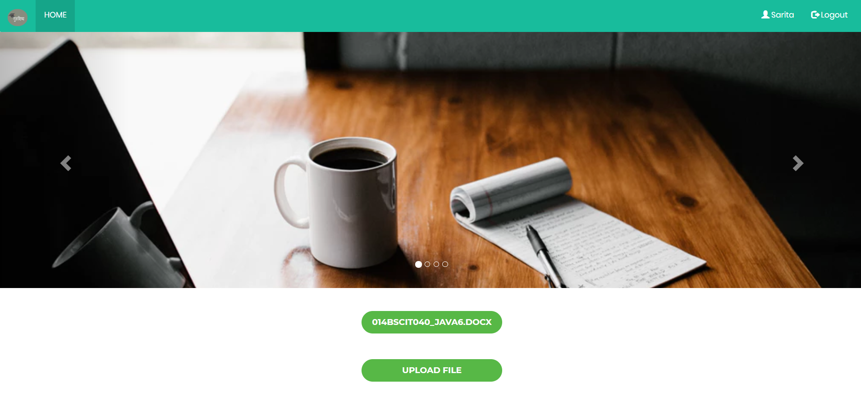

Fig 1: Upload file page

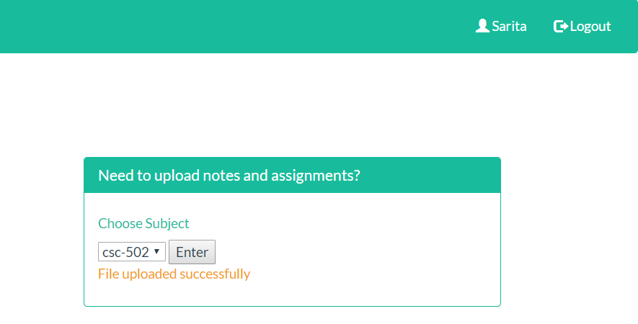

Fig 2: Upload success message

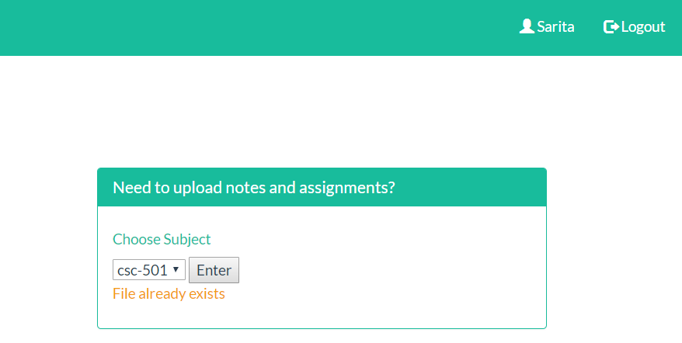

Fig 1: Upload fail message

The above figure shows the notes or assignments uploaded by the teacher from the local drive and then upload it successfully. If the file size is too large or same file is uploaded error occurs.

**3.5.2.2 Test Case 2**

**Test Objectives:** Test for submitted assignments view by teacher

**Test Performed:** View the submitted assignment of respective subject only

**Output:** Submitted Assignments of respective subject only seen

**Evidence:**

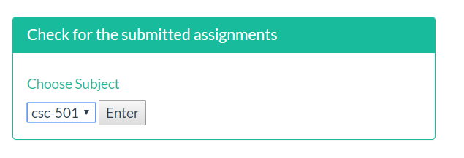

Fig 4: Selecting only respective subject

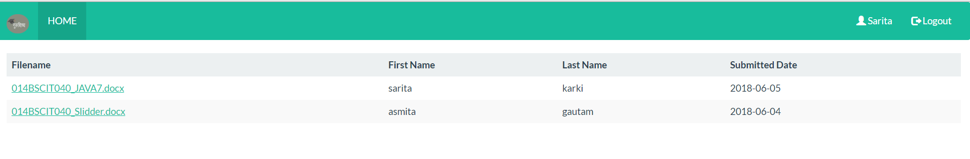

Fig 5: List of assignments with name and submission date

In the above figures the teacher can choose only the subject taught and then can see and download the assignments of respective subject.

**3.5.2.3 Test Case 3**

**Test Objectives:** Test for review view by teacher

**Test Performed:** View only his/her review

**Output:** List of review provided by student

**Evidence:**

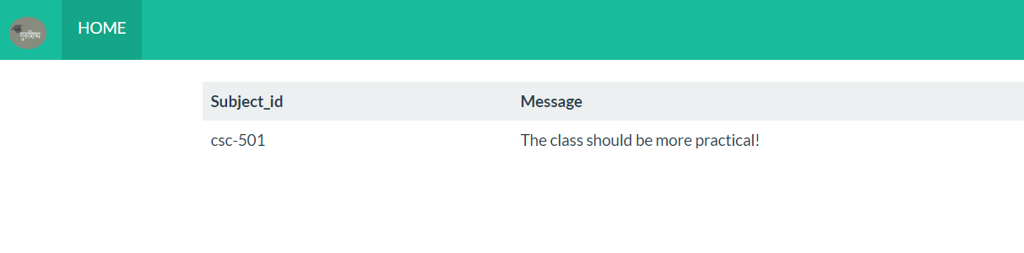

Fig 6: Review

Fig 6 above shows the feedback provided by student. Each feedback is secretive and can be seen by the teacher, who is logged into the system, his/her review only.

**3.5.2.4 Test Case 4**

**Test Objectives:** View the new assignments by student

**Test Performed:** View assignments of subject selected

**Output:** List of assignment of selected subject

**Evidence:**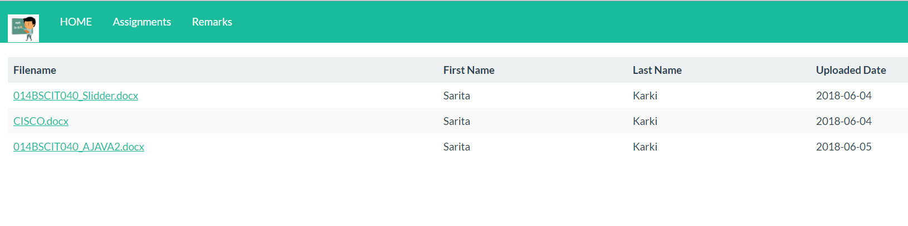

Fig 7: List of assignments for selected subject

Figure above shows the list of assignments of selected subject.

**3.5.2.5 Test Case 5**

**Test Objectives:** Give feedback by the student

**Test Performed:** Provide feedback

**Output:**  Feedback submitted successfully

**Evidence:**

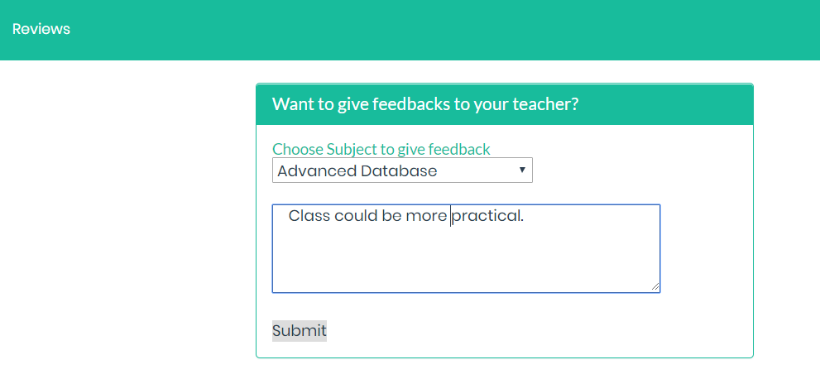

Fig 8: Giving feedbacks

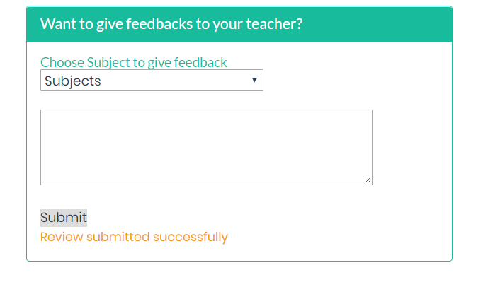

Fig 9: Response for feedback submission

**3.5 Implementation**

The implementation phase involves putting the project plan into action. It is the phase where you and your project team do the project work to produce the deliverables.

System implementation ensures that the system meets the quality standards. It is the test program that exercises the complete system in its actual environment to determine its capabilities and limitations which also demonstrates that the system is functionally operative and is compatible with the other subsystems and supporting elements required for its operational deployment. The implementation phase is where you and your project team do the project work to produce the deliverables i.e. anything your project delivers. The deliverables for your project include all the products or services that you and your team are performing for the client, customer, or sponsor, including all the project management documents that you put together [12].

Hence, implementation is the carrying out, execution, or practice of a plan, a method, or any design, idea, model, specification, standard or policy for doing something. As such, implementation is the action that must follow any preliminary thinking for something to happen [13].

The implementation of this project can be done in schools and colleges where assignments are given to the student in regular basis. This can be implemented in almost all the schools and colleges initiating from few in numbers. If provided proper hosting this project can take a wide popularity.

**CHAPTER 4: RESULT ANALYSIS**

**4.1 Screenshots**

**4.1.1 Login**

if (userid.equals(rs.getString("uname")) && pwd.equals(rs.getString("passwd"))) {

session.setAttribute("userid", userid);

session.setAttribute("user_id",rs.getString("id") );

}

else {

session.invalidate();

request.setAttribute("errorMessage", "Invalid username or password");

}

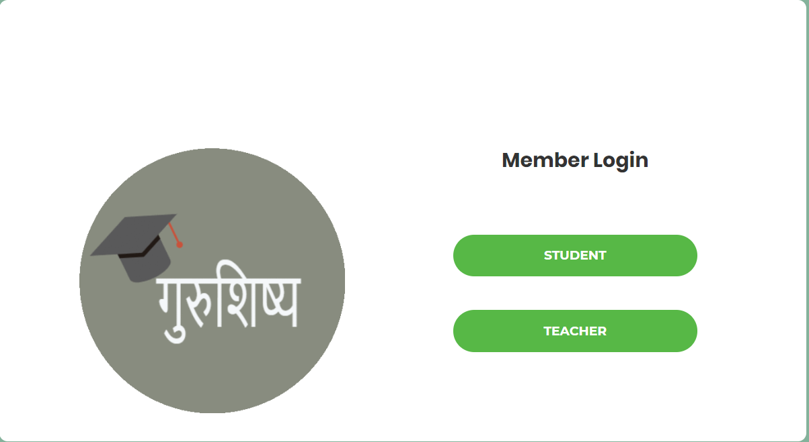 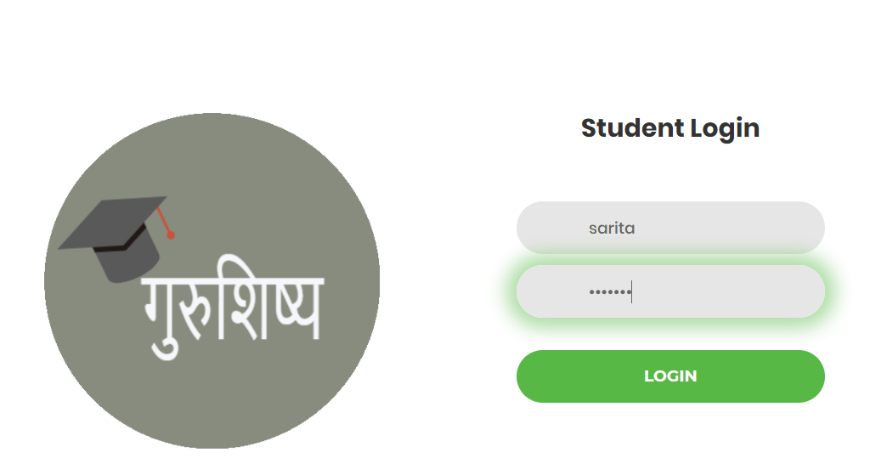

Fig 10:Login Page

The figure above shows the login page after the user opens the page. The login page has two options for member login, one for the teacher and one for the student. Here, the login for the student is shown. After the login the user goes to the main page.

**4.1.2 Upload notes and assignments**

if( fileName.lastIndexOf("\\") >= 0 ) {

file = new File( filePath +

fileName.substring( fileName.lastIndexOf("\\"))) ;

} else {

file = new File( filePath +

fileName.substring(fileName.lastIndexOf("\\")+1)) ;

}

fi.write( file ) ;

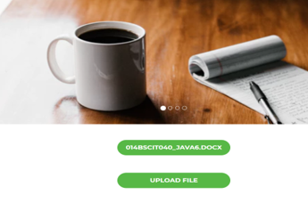 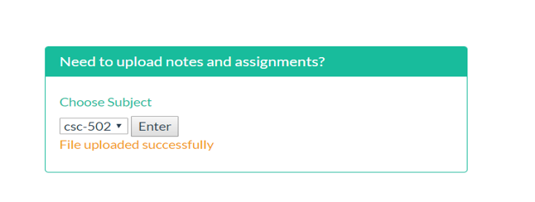

Fig 11: Uploading Assignments

The above figure is the figure of page after the user chooses the option to upload the for the particular subject. After uplaoding the file a message will be displayed as shown above. Eventually, the file will be saved in the database from where another user can retrieve.

**4.1.3 Search and download assignments**

ResultSet rs;

rs = st.executeQuery("select file, subject_id from assignment a where a.subject_id='" + subid + "' and a.student_id='" + user + "'")

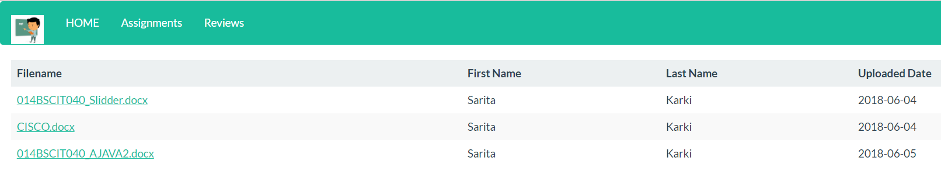



Fig 12: Viewing and downloading assignments

The above figure shows the page which is loaded after the user chooses to view the assignments of selected subject. After viewing the list, the users can download it as per their need.

**4.1.4 Provide Feedbacks**

int i = st.executeUpdate("insert into review(subject_id,message) values ('" + subid + "','" + remarks + "')");

if (i > 0) {

response.sendRedirect("remarks.jsp?success=success");

} else {

response.sendRedirect("remarks.jsp?notsuccess=fail");

}

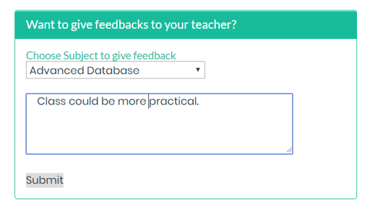 

Fig 13: Submitting Feedbacks

The figure above shows the page when the student chooses the subject to provide feedbacks. After submitting the feedbacks, a message will be shown as above. Eventually, the remarks will be stored in the database which the teacher will retrieve.

**4.2 Critical Analysis**

The project **गुरुशिष्य – “A Project for Easier Assignment Management”** was developed to help the teacher and students for the easier assignment provision and submission respectively. In the modern era of technology where people choose everything software-based services, this application would provide a platform where both the student and teacher can use the technology to share, upload and download the assignments and notes. Today in this era hard copies are less used. It is hectic for teacher to handle the assignments in the form of papers. So, this application lets the teacher to download and view the assignments and check the deadlines as well.

During the research phase the author went through different papers and journal articles. The research was carried out extensively to get as more knowledge as possible. From, the research, the author gathered a lot of information and knowledge regarding the assignment management under the knowledge management and the tools for the development of the app. From, the research, the author concluded that software-based assignment and knowledge management is an important issue in the schools and colleges of Nepal and thus this web-based technology could play a major role in bringing about a change.

For the project, author researched on the work done by other developers in the field of knowledge management and online assignment management system(AMS) in Nepal and around the world. Authors found many developers who are working actively to develop the app in the countries like USA, UK, India have developed such apps. In our country Nepal few have been developed but has not been in intense use and they do not use the web-based technology.

As per the system, it was developed for web app users as web apps are being used in large number nowadays. Upload and download of the files is easier via the computers than mobile. With the large screen on computers users can view the files easily and clearly. Likewise, web app can give you an easier user interface with the distinct view. So, web app for this project was chosen. For web app development the IDEs are: Eclipse, NetBeans, IntelliJ etc. Being familiar with the IDE NetBeans was used to develop the app.

Comparing between Eclipse and NetBeans, the author found that Eclipse’s functionality comes from plugins. Features like Mobile application SDK’s, Rich Internet applications, and Architectural driven apps can be developed using plugins mostly. On the other hand, NetBeans has many projects and is a tool-based IDE. It incorporates many platforms using tooling support. Thus, making it less scattered. It also has a strong support when you are developing MVC based application in Java. Servlet/JSP development is fairly very simple compared to Eclipse, especially in the field of deployment and debugging. NetBeans comes with in-built support for and SQL, MySQL and Oracle drivers plus it includes some others too. So, this makes things easy for developers. However, Eclipse has JDBC driver support – but it takes some serious time to configure the connection and takes higher amount of RAM space with high CPU speed to function properly.

Hence, NetBeans, an IDE for web app was selected to develop the web application. The user interface was designed using bootstrap via Java Server Pages(JSP). The authors wanted to enhance their knowledge in java also. So, java as well as JSP programming platforms were used to write the business logic.

Xampp was used as a web server solution stack as it makes it extremely easy for developers to create a local web server for testing and deployment purposes. Everything needed to set up a web server – server application (Apache), database (MySQL), and scripting language (JAVA) is included in a single extractable file. MySQL database was used as it is easy to use, has fast performance and is inexpensive. JAVA was used for server-side scripting as it is renowned for its Write One, Run Anywhere (WORA) philosophy, and indeed Java can be run on all major Web servers and all major operating systems. Java Web applications can also be bundled up into a standard Web Application Archive (.WAR) files that can then be installed on any Java-enabled Web server, no matter the platform.

From a developer’s perspective, authors have tried to develop a platform with easy user interface and tried to keep it simple and attractive. The author has tried to do strong backend coding to validate data and files and uphold possible errors and bugs. Also, databases are managed in such a way that the required data will be generated fast. One of the limitations of the web app is that it requires internet access to be dynamic among all the users and data to be stored in the server. Similarly, not all the users will use the desktop every time and everywhere.

**4.3 Limitation and Future Enhancement**

**4.3.1 Limitation**

* Unable to send the notification to the users about new files being uploaded.
* Unable to upload the file to the server without internet access.
* Unable to warn student few days before the deadline.
* There is chance of uploading the wrong file by user

**4.3.2 Future Enhancement**

* Sending notification to the user about the upload of new file
* Warning the students about the deadlines
* Making the app more dynamic

**CONCLUSION**

This project emphasizes on maintaining a well-organized assignment management system for both the teachers and students. The main objective of the project is to organize the assignments, notes and files easily via the use of web app without using hard copies. **गुरुशिष्य – “A Project for Easier Assignment Management”** was developed to help teachers and students to be connected using the same platform.

This project wouldn’t have been accomplished if various series of research were not conducted at various level. To get more idea on the topic, I started to research on the different related projects. The research included of searching for both the advanced as well as less advanced project than this. The research gave me a broader knowledge on how I could carry out this project more effectively. Thus, we I came up with the idea of developing this app.

A lot of effort and time has been used to research about the tools to be used for the development of the system. And only the tools that best fit the requirements if this system have been selected. The project was made for the web-based devices like desktops, considering that it is best suited for this kind of app. I have used bootstrap for the templates, JavaScript as the client-side validation, jQuery for simplifying the work of HTML and JSP and Java for the server-side scripting. MySQL has been used as the database that stores all the information. Ant browser like Mozilla, Chrome can be used for this web app.

Finally, this project has been accomplished after months of hard work and research. The result of all these hard work and patience has now led to a properly functioning system that would be helpful to manage a well-organized classroom. Therefore, this application helps the student be punctual and teacher be more enthusiastic in teaching.

**References:**

[1] "What is project management?", *Apm.org.uk*, 2018. [Online]. Available: https://www.apm.org.uk/resources/what-is-project-management/. [Accessed: 03- Jun- 2018].

[2] "What is Project Management?", *Pmi.org*, 2018. [Online]. Available: https://www.pmi.org/about/learn-about-pmi/what-is-project-management. [Accessed: 03- Jun- 2018].

[3] Techopedia.com. (2018). What is NetBeans? - Definition from Techopedia. [online] Available at: https://www.techopedia.com/definition/24735/netbeans [Accessed 03 Apr. 2018].

[4] [Online]. Available: <https://java.com/en/download/faq/whatis_java.xml.>

[5] DaniWeb, "Articles tagged with java," DaniWeb, 2016. [Online]. Available:

<https://www.daniweb.com/tags/java>.

[6] Tutorialsweb.com. (2018). MySQL. [online] Available at: <https://www.tutorialsweb.com/sql/mysql.htm#Introduction>

[7] "System Analysis and Design Overview", *www.tutorialspoint.com*, 2018. [Online]. Available: https://www.tutorialspoint.com/system_analysis_and_design/system_analysis_and_design_overview.htm. [Accessed: 03- Jun- 2018].

[8] "What is Systems Analysis? - Definition from Techopedia", *Techopedia.com*, 2018. [Online]. Available: https://www.techopedia.com/definition/9611/systems-analysis. [Accessed: 03- Jun- 2018].

[9] "What is Java Server Page (JSP)? - Definition from WhatIs.com", TheServerSide.com, 2018. [Online]. Available: https://www.theserverside.com/definition/Java-Server-Page-JSP. [Accessed: 04- Jun- 2018].

[10] "Unit Testing - Software Testing Fundamentals", *Software Testing Fundamentals*, 2018. [Online]. Available: http://softwaretestingfundamentals.com/unit-testing/. [Accessed: 04- Jun- 2018].

[11] "What is a Data Flow Diagram", *Lucidchart*, 2018. [Online]. Available: https://www.lucidchart.com/pages/data-flow-diagram. [Accessed: 04- Jun- 2018].

[12] "What is an Entity-Relationship Diagram (ERD)? - Definition from Techopedia", Techopedia.com, 2018. [Online]. Available: https://www.techopedia.com/definition/1200/entity-relationship-diagram-erd. [Accessed: 04- Jun- 2018].

[13] "Use case diagrams are UML diagrams describing units of useful functionality (use cases) performed by a system in collaboration with external users (actors).", *Uml-diagrams.org*, 2018. [Online]. Available: https://www.uml-diagrams.org/use-case-diagrams.html. [Accessed: 04- Jun- 2018].

[14] "Sequence diagram", En.wikipedia.org, 2018. [Online]. Available: https://en.wikipedia.org/wiki/Sequence_diagram. [Accessed: 04- Jun- 2018]

[15] *Guru99.com*, 2018. [Online]. Available: <https://www.guru99.com/system-testing.html>. [Accessed: 04- Jun- 2018].

[16] Project Implementation Overview – Project Management", *Opentextbc.ca*, 2018. [Online]. Available: https://opentextbc.ca/projectmanagement/chapter/chapter-17-project-implementation-overview-project-management/. [Accessed: 06- Jun- 2018].

[17] "What is implementation? - Definition from WhatIs.com", *SearchCRM*, 2018. [Online]. Available: https://searchcrm.techtarget.com/definition/implementation. [Accessed: 06- Jun- 2018].